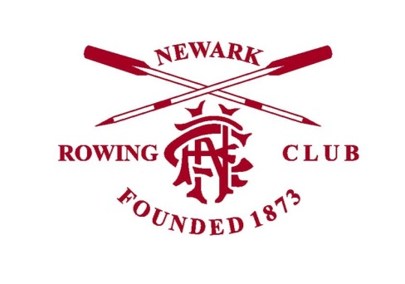
The Clubhouse Booking Form

Name
Company
Address
Mobile
Email
Date of event
Reason for event
(e.g. 40th birthday party)
Number of guests (approx)
Any specific bar requests?
Do you require refreshments?
Tea/Coffee/Biscuits?
What time do you require access to the building?
Set up time & event time
What time will your guests arrive?
Do you require use of the kitchen?
Any other information

ROOM HIRE RATES
- Daytime hire - £35 per hour. Room only does not include bar
- Tea/Coffee/Biscuits - £2 per head
- Evening hire - £100 7pm – 11.30pm
- Bar staff - £10 per hour. Minimum 2 people
A £50 deposit will be required upon booking
48 hours notice is needed for all cancellations.
Full payment is required at least 5 working days before the event.

